Computer Architecture – Mini Paper

Week 1 to Week 5
Time: 1 Hrs

Section A:MCQs
Q1. A processor designer must choose between two ISA styles for a beginner-friendly pipelined CPU.
- Design A allows arithmetic directly on memory operands.
- Design B forces arithmetic to use registers, and memory is accessed only by explicit load/store instructions.
Which design is more naturally suited for simple fast datapath implementation and why?
a) Design A, because it reduces the number of instructions
b) Design A, because memory access is always faster than register access
c) Design B, because it simplifies datapath and control
d) Design B, because it eliminates the need for ALU control

Q2. A student runs a loop that repeatedly updates one variable and also scans an array sequentially. Which option best describes the memory behavior?
a) Only spatial locality is present
b) Only temporal locality is present
c) Both temporal and spatial locality are present
d) Neither temporal nor spatial locality is present

Q3. In a single-cycle processor, the instructor says the lw instruction is often the one that determines the clock period. What is the best explanation?
a) Because lw uses the fewest hardware units
b) Because lw passes through more major structures in one instruction path
c) Because lw does not use the ALU
d) Because lw avoids memory access delay

Q4. A processor uses one unified memory for both instruction fetch and data access. During execution of a load instruction, the next instruction also needs to be fetched. Which issue is most likely?
a) Temporal locality
b) Structural conflict
c) Register renaming
d) Branch prediction error

Q5. A direct-mapped cache performs poorly for a program that repeatedly alternates between two memory blocks even though the cache is not very small. What is the most likely reason?
a) Capacity miss only
b) Compulsory miss only
c) Conflict behavior due to mapping
d) Write-back overhead only

Section B: Short Questions
Q6. A student argues:
“Since CISC may use fewer instructions than RISC, it must always be faster.”
Give two architecture-based reasons why this conclusion may be wrong.

Q7. A cache designer doubles the cache block size to exploit spatial locality. State one likely benefit and one likely trade-off of this choice.

Q8. A machine has a high clock speed, but users still report slow application performance when working with large arrays. Using memory-system concepts, explain one likely reason.

Section C: Analytical Questions
Q9. A company is evaluating two educational CPU designs for a lab course.

Design X
- fixed-length instructions
- load-store style
- simpler control logic
- may require more instructions for some tasks

Design Y
- more complex instructions
- some operations can directly involve memory
- fewer instructions for some tasks
- more complex decoding and control
The company asks you to recommend one design for a first processor-design course where students must understand:
- ISA,
- datapath,
- control,
- and performance trade-offs.
Write a short analytical response in which you:
- choose one design,
- justify it using datapath/control reasoning,
- and explain one trade-off you are accepting by making that choice.

Q10. A processor designer builds a simple single-cycle MIPS-like CPU that supports:
- add, addi ,lw ,sw ,beq
During testing, the CPU works correctly but performs poorly.
The designer makes the following claim:
“Our CPI is 1, so this processor is already efficient.”
Evaluate this claim analytically. In your answer, discuss:
- why CPI alone is not enough,
- why the longest instruction path matters,
- and how memory access influences overall performance.

Diagram-Based Analytical Question
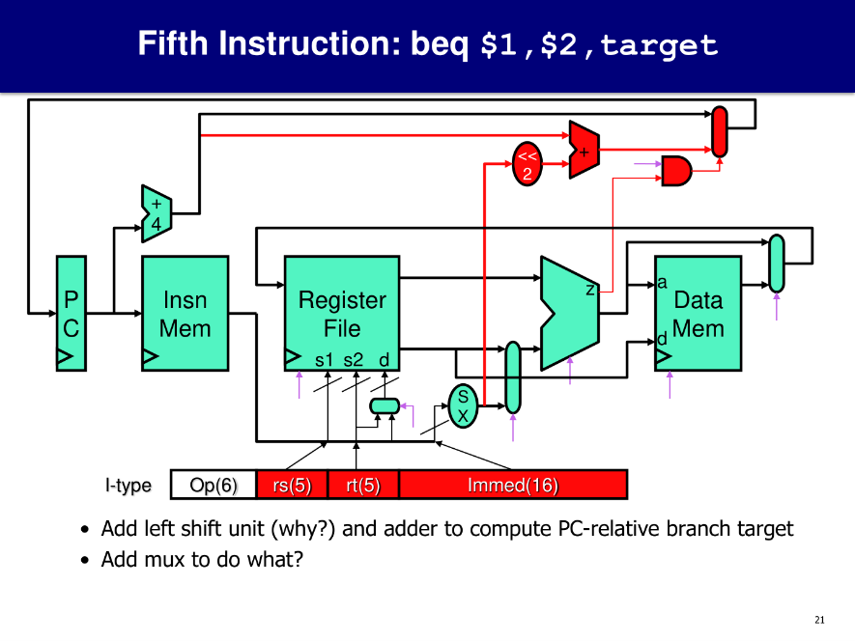
Figure A: Datapath for beq
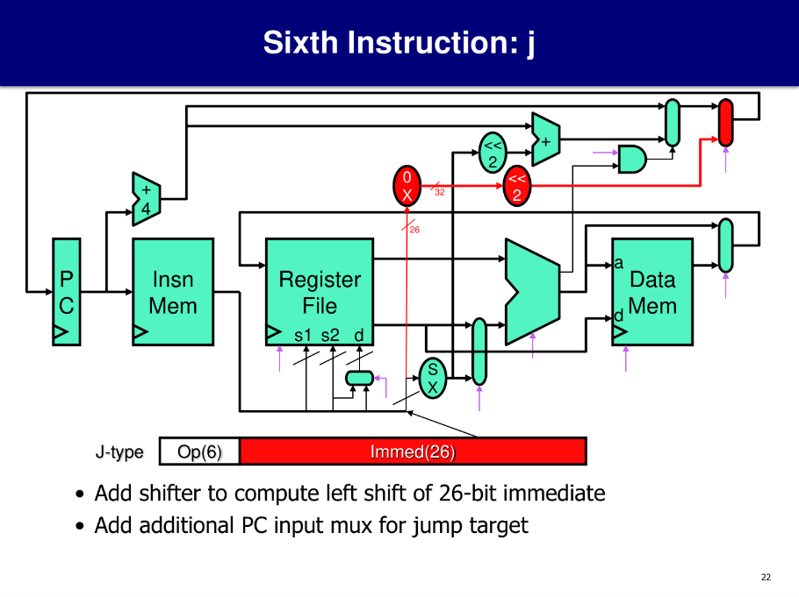
Figure B: Datapath for j

Question 12. Study the two datapath diagrams above for beq and j. Both instructions can change the value of the Program Counter (PC), but the hardware added for them is not the same.
- Explain why beq needs a comparison result before the PC can be updated.
- Explain why j does not need that same comparison step.
- Using the diagrams, discuss how the shift unit, adder, mux, and control path help produce two different kinds of next-instruction addresses.
Instruction for students: Do not simply list component names. Use the logic of each datapath to explain how the next PC value is chosen in each case.

Teacher Key / Expected Direction

Section A
- c
- c
- b
- b
- c

Section B – expected reasoning
Q6: Fewer instructions alone does not guarantee speed; complex instructions may increase decode/control complexity, cycle time, or make pipelining harder.
Q7: Benefit: better use of spatial locality. Trade-off: larger miss penalty or fewer blocks in cache.
Q8: Memory hierarchy/cache behavior may be poor; large-array accesses may suffer from misses and memory delay.

Section C – expected reasoning

Q9: Strong answers will usually prefer Design X for teaching because it makes datapath/control easier to reason about, aligns better with simple pipelined-style thinking, and clearly separates memory access from computation. Trade-off: may require more instructions.
Q10: Strong answers must reject the claim that CPI=1 alone means efficient. They should explain that single-cycle designs can still be slow because the clock period must accommodate the slowest instruction path, especially lw, which touches several major structures including memory.
Q11: beq and j can both change the Program Counter, but they do so for different reasons, so the datapath support for them is also different.
In the case of beq, the processor cannot update the PC immediately just from the instruction format alone. It must first compare the two register values to decide whether the branch condition is true. That is why the datapath includes comparison-related logic through the ALU and a branch control path. The branch target is also not taken directly from the instruction as a full address. Instead, the immediate field is sign-extended, shifted left by 2, and then added to PC + 4 to form the PC-relative target address. A mux is needed so the processor can choose between the normal next instruction (PC + 4) and the branch target. In other words, beq is a conditional control transfer, so the next PC depends on both the computed target and the comparison result.
In the case of j, the processor does not need to compare register values because jump is unconditional. Once the instruction is decoded as a jump, the processor already knows that control must move to a new address. The datapath therefore does not need the ALU comparison result for the decision. Instead, it needs hardware to construct the jump target from the instruction’s immediate field. That is why the jump datapath includes a shift-left-by-2 operation on the jump immediate and an additional PC-selection path. The mux chooses the jump target whenever the jump control signal is asserted. So j is a direct control transfer, not a conditional one.
The key difference is that beq decides the next PC based on a condition, while j decides it directly from the instruction type. This is why beq needs comparison hardware and branch decision logic, whereas j mainly needs target-construction hardware and PC redirection logic.
Main points expected in a strong answer:
- beq is conditional; j is unconditional.
- beq must compare register values before choosing the next PC.
- beq uses sign extension, shift-left-by-2, and an adder to build a PC-relative branch target.
- j does not need register comparison.
- j builds a jump target from the instruction field and redirects the PC directly.
- In both cases, muxes and control signals are necessary to select the correct next PC path.

